**Q1.**

hrs=42

min=30

sec=hrs*3600+min*60

print(sec)



**Q2.**

def avg(*h):

  avg=sum(h)/len(h)

  print(avg)

avg(1,2,3,4)



**Q4.**

a=input("Enter a number")

for i in a:

  if int(i)==1:

    print("One")

  elif int(i)==2:

    print("Two")

  elif int(i)==3:

    print("Three")

  elif int(i)==4:

    print("Four")

  elif int(i)==5:

    print("Five")

  elif int(i)==6:

    print("Six")

  elif int(i)==7:

    print("Seven")

  elif int(i)==8:

    print("Eight")

  elif int(i)==9:

    print("Nine")

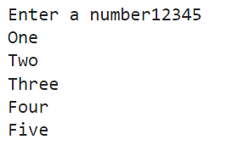

**Q5.**

class Maths:

  def Add(self,a,b):

    self.Add=a+b

    print(self.Add)

  def Div(self,a,b):

    self.Div=float(a/b)

    print(self.Div)

  def Sub(self,a,b):

    self.Sub=a-b

    print(self.Sub)

  def Mul(self,a,b):

    self.Mul=a*b

    print(self.Mul)

a=Maths()

a.Add(15,12)

a.Div(15,12)

a.Sub(15,12)

a.Mul(15,12)

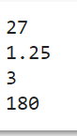

**Q6.**

for i in range(1,6,2):

    for j in range(1,i+1,2):

      print(i,end="")

    print()

for a in range(6,8):

    for j in range(1,a-1):

      print(a,end="")

    print()

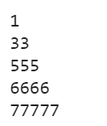

**Q9.**

a="This is a test"

for i in range(len(a)):

  if i%2!=0:

    print(a[i],end="")



R Program:

**A1.**

print("Sequence of numbers from 20-50")

print(seq(20,50))

print("Mean of numbers from 20-60")

print(mean(20:60))

print("Sum of numbers from 51-91")

print(sum(51:91))

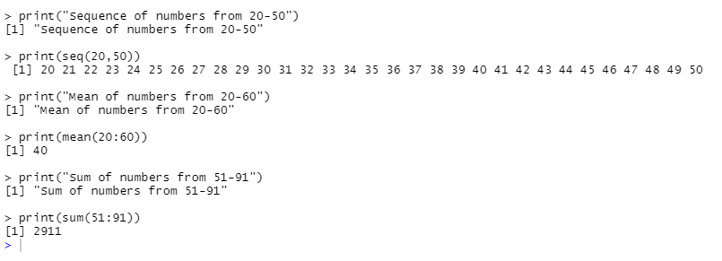

**A2.**

for (n in 1:100) {

if (n%%3==0 & n%%5==0) {print("FizzBuzz")}

else if (n%%3==0) {print("Fizz")}

else if (n%%5==0) {print("Buzz")}

print(n)

}

